PUBLIC TRANSPORT OPTIMIZATION

Abstract:

Thousands of students use school transportation around The world. We require a transportation system that is effective, reliable, safe, and smart. The suggested system depicts a transportation concept that provides real-time tracking, calculates optimal routes to destinations, detects intrusion, and assists in the maintenance of transportation system statistical data. IR sensors and RFID tags are used to create an IOT network. The detection of intrusion is done via facial recognition. Google Maps, GPS, and accelerometer data are used to detect live location. A bus-mounted Raspberry Pi Microcontroller interfaces with a centralized Firebase Cloud platform Design & thinking:

It uses RFID and GPS to Communicate to a remote server using Wi-Fi and an ESP8266 microcontroller. The RFID device is scanned for identification and information retrieval. Real-time data processing can help commuters get at their destination faster by reducing waiting time. The proposed work uses IOT with RFID, raspberry Pi, IR sensor, GPS, Firebase, and Google Maps to achieve features such as attendance analysis, notifying end-users with alighting and boarding alerts, location tracking through GPS by integrating Google Maps, Intrusion and accident detection, and cloud storage to expand the security framework and traceability aspects of the child

COMPONENTS:

The proposed system utilizes the following hardware and software components

Hardware Specifications:

The bus’s hardware is the most crucial Component. The hardware utilized for prototype Development is described in this section.

IR Sensor:

The proposed system uses an IR sensor as The first step in verifying the student’s entry into the bus. With a pair of infrared transmitters and a receiver tube, An IR Sensor module has an adaptable potentiality of Atmospheric light. Infrared technology is used in a Variety of wireless applications.

RFID Reader RC522:

The RFID RC522 Card Reader Module, based on the MFRC522 controller, is a low-cost 13.56 MHz RFID Reader module. The module necessitates a 3.3V power Supply. It can communicate with any CPU board directly Using the SPI protocol, and it also supports I2C and UART. It is utilized for attendance analysis and person Identification in the proposed system.

Raspberry Pi 3 B+ Micro-controller:

The Raspberry Pi foundation microcomputer that was created to promote programming and computing principles. It has a 64-bit quad-core processor with a clock speed of 1.4GHz and dual-band 2.4GHz. It has 5GHz wireless LAN and Bluetooth connectivity, making it an ideal alternative for highly networked designs. Its high processing power and on-board connectivity make it ideal for IOT applications.

Camera Module:

The 5-megapixel Camera Module Rev 1.3 is a specially developed Raspberry Pi add-on. A unique CSI interface is utilised for camera interaction. The CSI bus provides extremely high data speeds and consistently transports pixel data. It is used to capture a snapshot of the intruder in the proposed system.

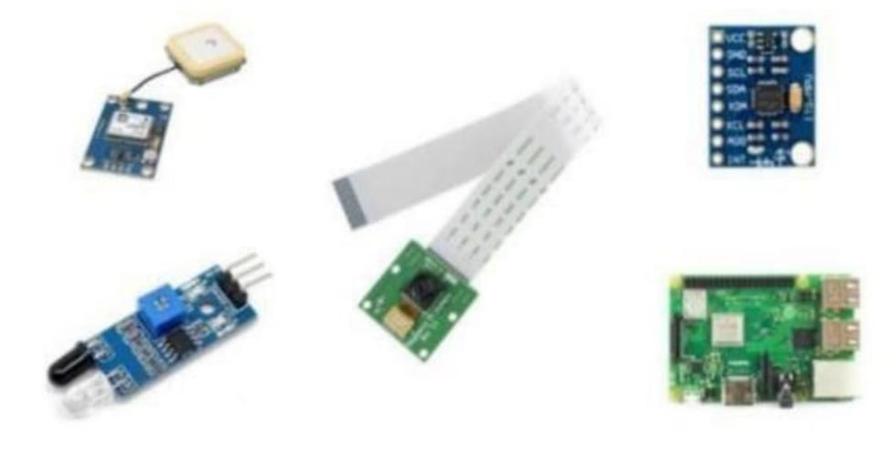

GPS Module –Neo 6M: The Neo-6M GPS module is a reliable GPS receiver with a 25 x 25 x 4mm ceramic antenna built in. It has a good satellite search capacity. The power and signal indicators can be used to check on the module’s status. It is used to gather information about geographical parameters.

MPU6050 Accelerometer:

The MPU6050 is a single-chip 3-axis accelerometer and gyroscope. It is also known as a six-axis motion tracking or six Degrees of Freedom (DOF) device because of the three accelerometer and three gyroscope outputs. Hardware components used in the prototype development

# Specifications for Software

HTML, JS, CSS, jQuery, and Bootstrap were used to create The android application. In order to view the current location, the Google Maps API has been integrated into the programmer. Using Firebase fire-store, we were able to get real-time changes Firebase:

The Firebase database is a cloud-based database that allows for real-time data syncing and storage across users around the world. It promotes user participation and server less application development. JSON is the format in which the NoSQL database is stored. When developing cross-platform programmer, a real time database instance can be shared among all clients. Even If the app goes down, the data is still accessible.

API for Google Maps:

Google has created application programming interfaces (APIs) that allow users to communicate with Google services and integrate them with other services. Analytics, machine learning as a service, and user data access are among the features. Google Maps can also be iIntegrated into a website or application. It is used in the suggested model to add a map to the Android app to detect bus routes and deliver the best way to destination with real-time traffic update

Node-RED:

Hardware components, APIs, and other web services are used to collaborate. Node-RED is a popular visual Programming tool that comes with a web-based editor. .JSON can be used to save the flows and share them with others . It is an event-driven and non-blocking approach that is based on node . The Raspberry Pi is being used in the current system.

PROPOSED SYSTEM ARCHITECTURE:

The suggested system seeks to provide effective services through the integration of various technologies and the Internet of Things. The suggested system’s diagrammatic representation.

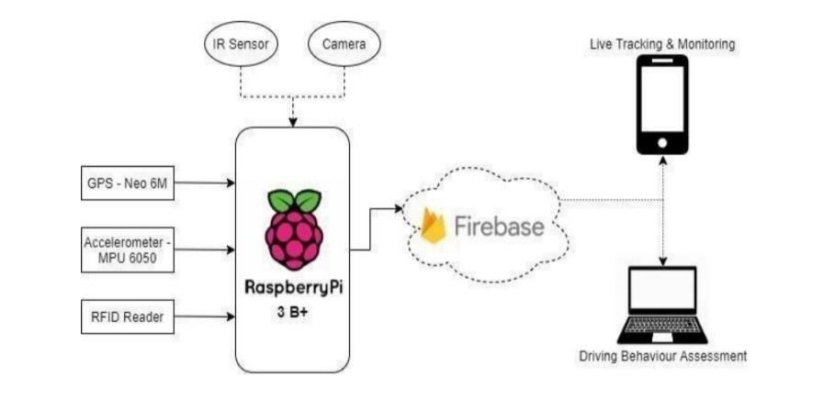

The various hardware prototype components that were used to construct the prototype. The Raspberry Pi serves as the system's brain, connecting to several sensors like as GPS, Accelerometer, RFID, IR, and Camera. For database management, it's also linked to Google Firebase. The Raspberry Pi and the Firebase have most of the data in sync.

The administrative, driver, and mobile apps are designed to keep everyone up to date on the latest Information, such as routes, live monitoring, attendance, and notifications.

Conclusion:

*The prototype was successfully implemented,* and the key functionalities of student detection via RFID, Intrusion detection, location tracking, and accident detection were all confirmed to be correct. Secondary capabilities such as attendance analysis, route estimates, cloud-storage of essential data, and custom alerts were also tested and found to work as expected. The prototype outperforms GSM and Arduino-based systems by combining GPS and Google Maps APIs to give live Location and real-time tracking